**Design a conceptual schema for The Following ERDs . Be sure to indicate all keys and cardinality constraints and any assumptions that you make**

**1- Airline**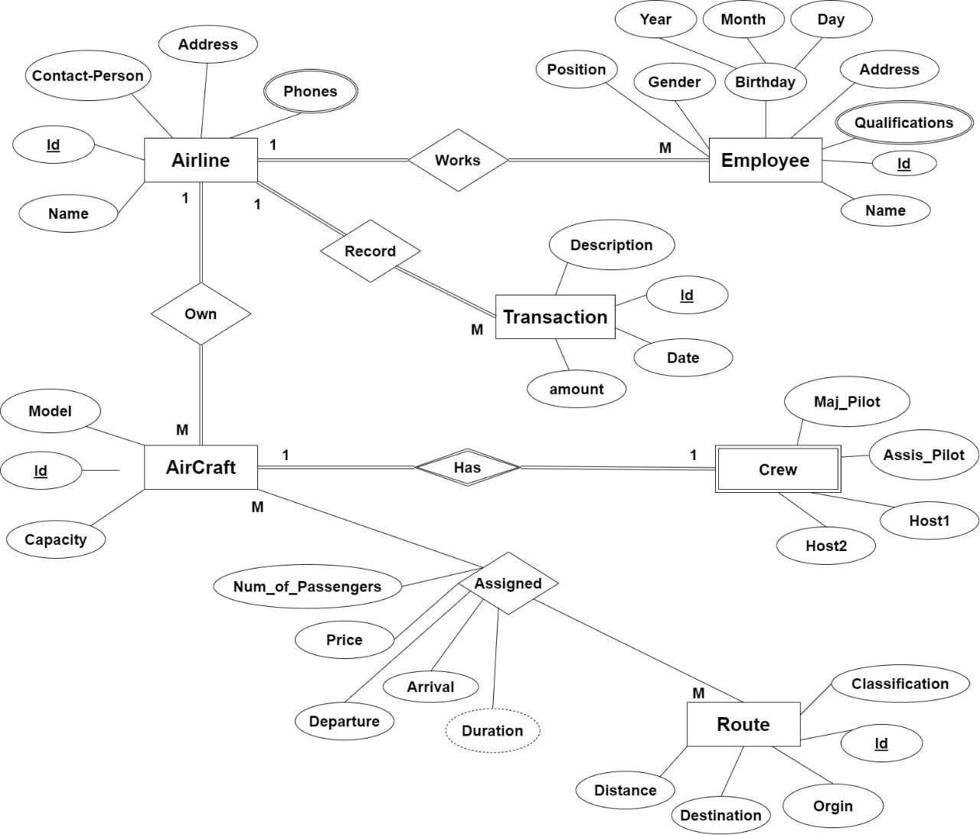

**2 - Hospital**

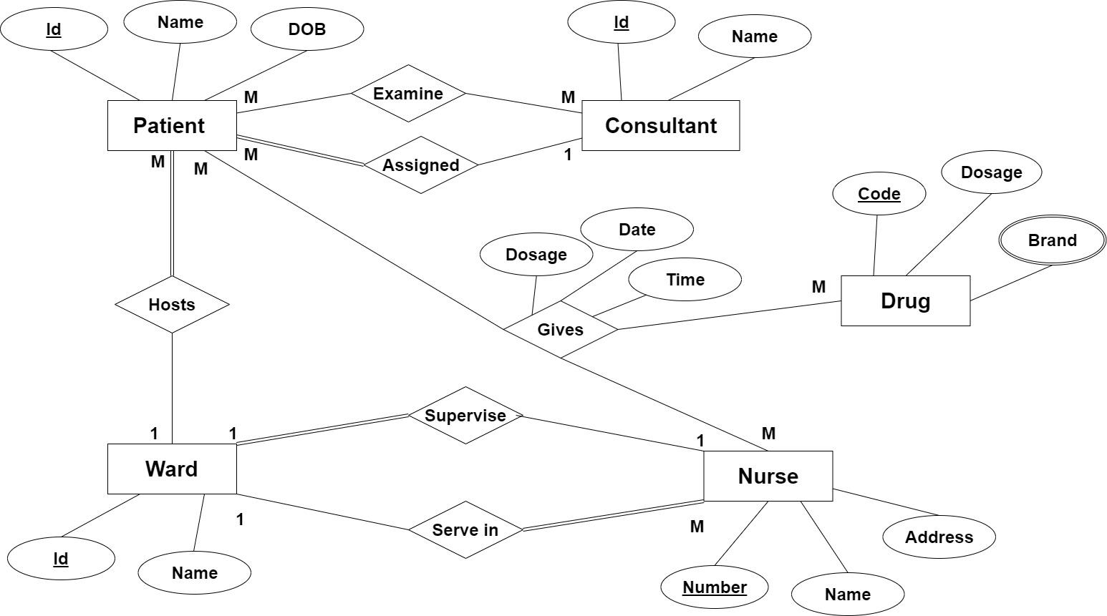

**3 - Musician**

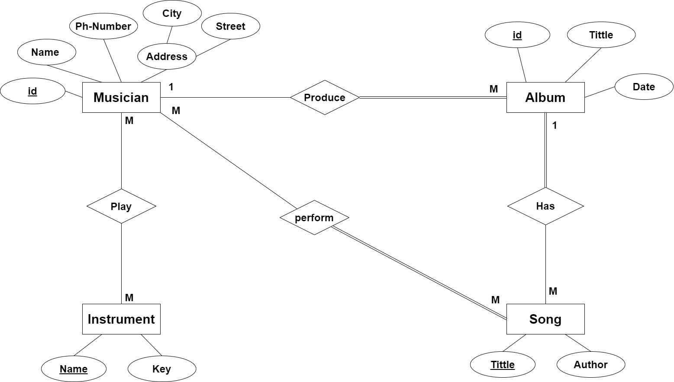

**4- Sales**

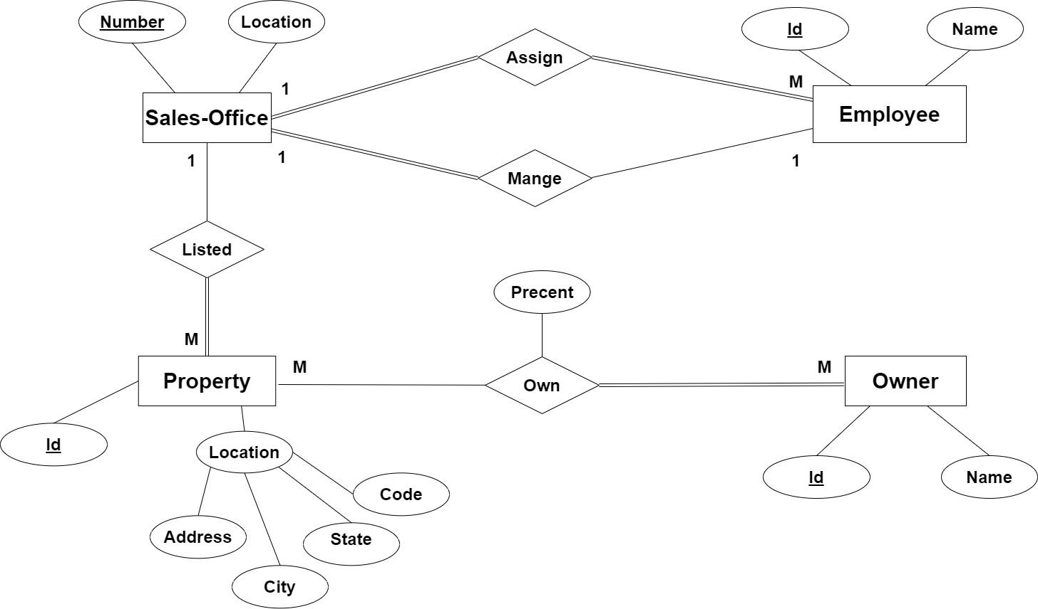

**5 - ITI**

